Differential Gene Expression Analysis of Breast Tumour vs Normal Tissue Using TCGA RNA-Seq Data
A Bioinformatics Analysis of The Cancer Genome Atlas (TCGA-BRCA) Dataset
Hafiza Suneeha Aamir
BS Biotechnology, Bahauddin Zakariya University (BZU), Multan
hafiza.suneeha.aamir0@gmail.com
October 2026

Background
Breast cancer is still the most commonly diagnosed cancer among women worldwide, and part of what makes it so hard to treat is how molecularly diverse it is. Gene expression profiling has played a big role in understanding this diversity. It has shown that breast tumors fall into a few distinct molecular subtypes, namely luminal A, luminal B, HER2-enriched, and basal-like, and each of these comes with a different prognosis and a different response to treatment (Thennavan et al., 2021). The Cancer Genome Atlas (TCGA) breast cancer cohort (TCGA-BRCA) has become one of the main resources researchers rely on for this kind of work, since it provides RNA-sequencing data for more than a thousand tumor and matched normal samples, which is more than enough to run large-scale differential expression and pathway analyses on (Thennavan et al., 2021).
Beyond just classifying subtypes, comparing tumor tissue directly against normal tissue is a useful way to find genes and biological processes that are broadly dysregulated in breast cancer, regardless of subtype. Recent transcriptomic studies that combine TCGA-BRCA with other public datasets have pointed to some recurring patterns, including dysregulation of extracellular matrix remodeling genes and cell cycle machinery, as consistent features of the breast tumor microenvironment (Noman et al., 2025). Two families of genes that keep showing up in this kind of work are collagens and matrix metalloproteinases. COL11A1, a minor fibrillar collagen that is mostly secreted by cancer-associated fibroblasts rather than the tumor cells themselves, is consistently overexpressed in breast tumor stroma, and it has been linked to poor prognosis, immune infiltration, and even resistance to endocrine therapies like tamoxifen (Shi et al., 2022; Fu et al., 2024). MMP11 shows a similar pattern. It was first identified in breast tumor stromal cells and is reliably overexpressed in breast cancer compared to normal tissue, where it contributes to tumor cell migration and immune cell recruitment within the tumor microenvironment (Kang et al., 2022).
This project takes on a smaller, more focused version of that same question. Which genes are significantly differentially expressed between primary breast tumor and adjacent normal tissue in the TCGA-BRCA cohort, and what biological processes do those genes actually regulate?

Methods
For this project, I used RNA-sequencing data from the TCGA-BRCA (Breast Invasive Carcinoma) cohort, which I accessed through the Genomic Data Commons (GDC) portal using the TCGAbiolinks package in R. I downloaded gene expression quantification data that had been generated using the STAR alignment and counting workflow. In total, this gave me 1,231 samples: 1,111 primary tumor samples and 113 matched normal tissue samples. There were also seven metastatic samples in the dataset, but I excluded these since I was specifically interested in comparing primary tumor to normal tissue, not metastatic disease.
To find out which genes were significantly different between the two groups, I used DESeq2, which is the standard tool for this kind of differential expression analysis on RNA-seq count data. Before running the actual analysis, I filtered out genes with very low read counts across all samples, since these mostly just add noise rather than any real biological signal. I then ran DESeq2 comparing tumor against normal, with normal tissue set as the baseline for comparison. I counted a gene as significantly differentially expressed if it had an adjusted p-value (padj) below 0.05 and an absolute log2 fold change greater than 1, which means its expression differed by at least two-fold between tumor and normal tissue.
To visualize what I was finding, I made a volcano plot to show the relationship between statistical significance and the size of the change across all genes, and a heatmap of the top 50 most significant differentially expressed genes to see how clearly tumor and normal samples separate based on expression alone. Finally, to understand what these genes were actually doing biologically, I converted the significantly upregulated genes into Entrez gene IDs and ran a Gene Ontology (GO) enrichment analysis for biological processes, using the clusterProfiler package in R and the Benjamini-Hochberg method to correct for multiple testing.

Results
After running the differential expression analysis on all 1,224 tumor and normal samples (1,111 tumor, 113 normal), I found 12,304 genes that were significantly different between breast tumor and normal tissue (adjusted p-value below 0.05, absolute log2 fold change above 1). Of these, 8,186 genes were upregulated in tumor tissue and 4,118 were downregulated. That alone told me something important before I even looked any closer. Breast cancer does not just involve a handful of genes going wrong. It involves a pretty widespread shift in the cell's whole gene expression program, with noticeably more genes being switched on than switched off.
The volcano plot (Figure 1) gives a good visual sense of this. Each dot is a gene, and the ones furthest from the center and highest up are the ones that changed the most and with the greatest statistical confidence. The single most significant gene in my entire dataset was MMP11, which was strongly upregulated, with a log2 fold change of 6.28, meaning roughly a 78-fold increase in tumor compared to normal tissue. Other genes among my top hits included COL10A1, NEK2, and COL11A1, all upregulated, along with MYOM1, GPAM, FHL1, and TNS1, which were downregulated. What struck me once I looked into these afterward is that several of them, especially MMP11 and COL11A1, are not obscure genes. They have already been reported independently in published cancer research as consistently overexpressed in breast tumors, which gave me more confidence that my analysis was actually picking up real biological signal and not just noise.
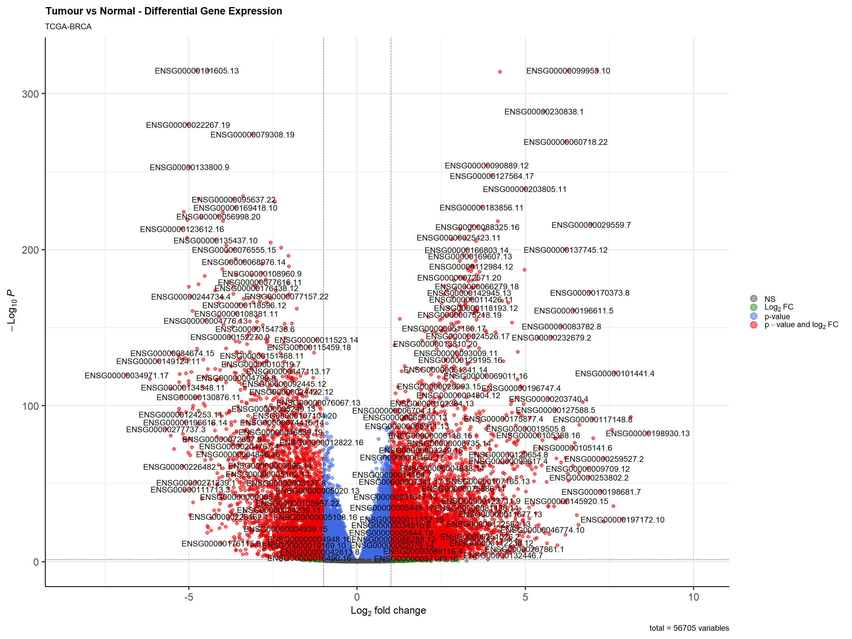
Figure 1. Volcano plot of differential gene expression between breast tumour and normal tissue (TCGA-BRCA). Each point represents a gene. Genes with greater statistical significance and larger fold change appear toward the top and outer edges of the plot.
The heatmap in Figure 2 made this separation even more visible. When I clustered samples based only on the expression of the top 50 differentially expressed genes, tumor and normal samples largely grouped apart from each other on their own, without me telling the clustering algorithm which sample was which beforehand. That kind of clean separation is a good sign that the differences I found are not just random noise.
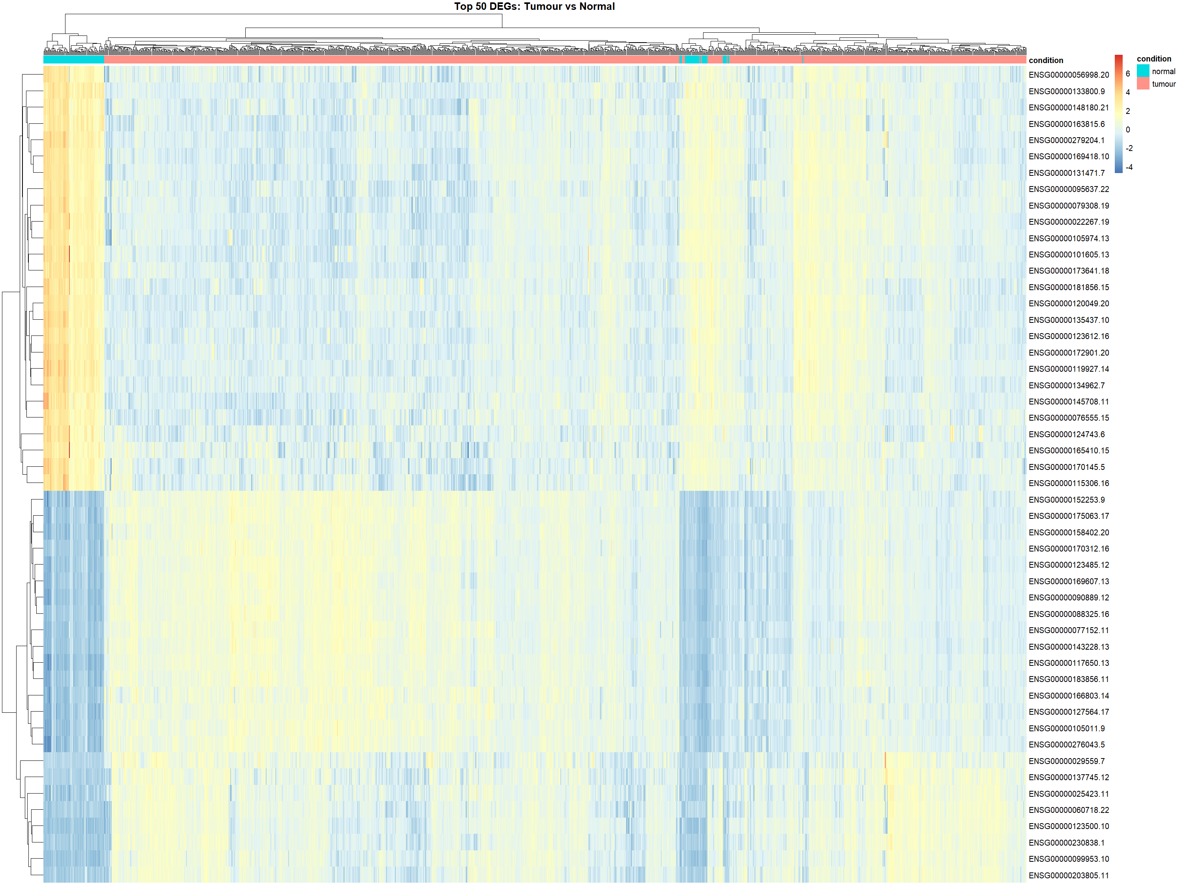
Figure 2. Heatmap of the top 50 differentially expressed genes across all samples, with hierarchical clustering of samples (columns) and genes (rows). The colored bar at the top marks tumour (salmon) versus normal (teal) samples.
Table 1 summarizes the ten most statistically significant differentially expressed genes I found in this analysis.
Gene | log2FC | Fold change | Adjusted p-value | Direction
MMP11 | +6.28 | ~78× | < 0.0001 | Up
COL10A1 | +7.13 | ~140× | < 0.0001 | Up
NEK2 | +4.25 | ~19× | < 0.0001 | Up
LINC01614 | +5.56 | ~47× | < 0.0001 | Up
COL11A1 | +6.20 | ~74× | < 0.0001 | Up
KIF4A | +3.85 | ~14× | < 0.0001 | Up
MYOM1 | -4.76 | ~27× lower | < 0.0001 | Down
GPAM | -4.43 | ~22× lower | < 0.0001 | Down
FHL1 | -5.03 | ~33× lower | < 0.0001 | Down
TNS1 | -3.11 | ~8.6× lower | < 0.0001 | Down
Table 1. Top 10 most significant differentially expressed genes between breast tumour and normal tissue, ranked by adjusted p-value.
To understand what the upregulated genes were actually doing biologically, I ran a Gene Ontology enrichment analysis for biological processes on all 8,186 upregulated genes. The top enriched terms, shown in Figure 3, were strongly related to cell division and genome maintenance, including the following:
- Organelle fission
- Nuclear division
- Chromosome segregation
- Nuclear chromosome segregation
- Mitotic sister chromatid segregation
- Cell cycle checkpoint signaling
- Nucleosome organization / assembly
This pattern fits well with what you would expect from cancer, since uncontrolled proliferation is really the defining feature of the disease.
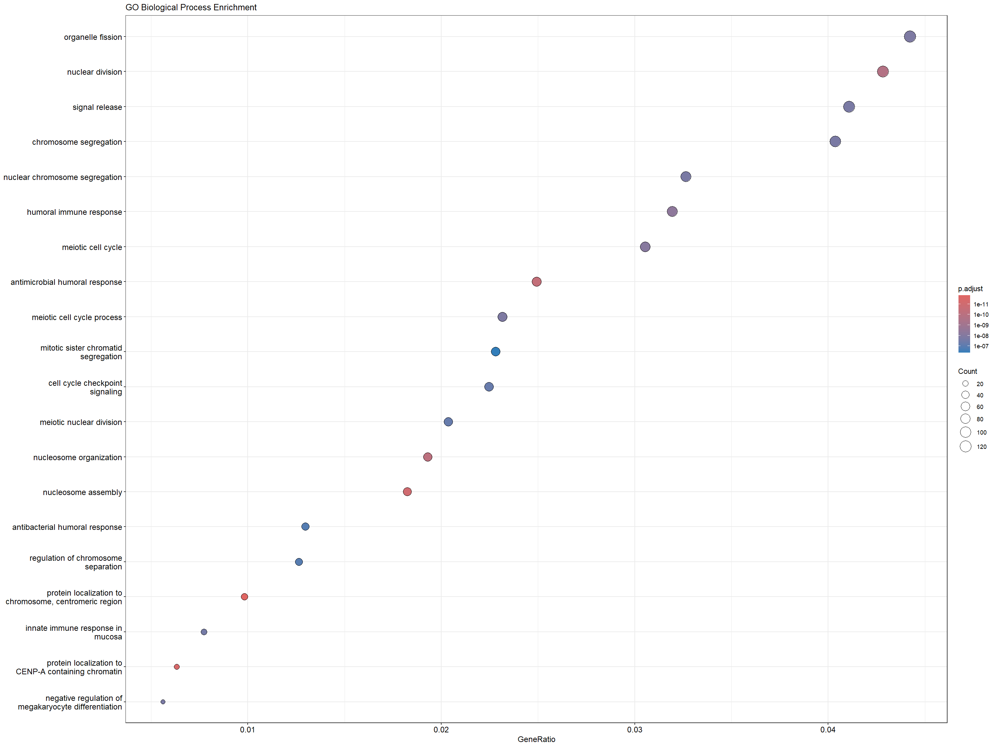
Figure 3. Top 20 enriched Gene Ontology biological process terms among significantly upregulated genes. Dot size reflects gene count per term, and color reflects adjusted p-value.

Discussion
Looking back at everything I found, the results line up pretty well with what is already known about breast cancer biology, which was reassuring since this was my first time running an analysis like this from start to finish. The two genes with the strongest upregulation in my dataset, MMP11 and COL11A1, are both well documented in the literature as being consistently overexpressed in breast tumor tissue. MMP11 was actually one of the first genes identified in breast tumor stromal cells, and it has repeatedly been shown to be overexpressed in breast cancer compared to normal tissue (Kang et al., 2022). COL11A1 has an even more developed body of evidence behind it. It is secreted mainly by cancer-associated fibroblasts rather than the cancer cells themselves, and its overexpression has been linked not just to the presence of a tumor but to poor prognosis, immune cell infiltration, and resistance to tamoxifen, a drug commonly used for hormone-receptor-positive breast cancer (Shi et al., 2022; Fu et al., 2024). Seeing both of these genes land right at the very top of my own results, without me expecting that going in, was honestly the moment this project stopped feeling like just an exercise and started feeling like something real.
The GO enrichment results reinforced this even further. The upregulated genes were dominated by cell division and chromosome segregation processes, which fits with the basic biology of cancer. Tumor cells divide when they should not, so it makes sense that the machinery responsible for that division becomes more active. I did not go into this analysis expecting any particular pathway to dominate, so watching this pattern emerge cleanly from the data, rather than being something I was already looking to confirm, made the result feel a lot more convincing to me.
A few things in my results were less expected, or at least worth a closer look. I had not really anticipated how large the number of significantly differentially expressed genes would turn out to be. Over twelve thousand genes met my significance threshold, which is a substantial fraction of all protein-coding genes. Part of this comes down to how large the TCGA-BRCA sample size is. With over a thousand tumor samples, even small and consistent differences become statistically detectable. A smaller study with fewer samples would likely not reach significance for anywhere near as many genes, even if the underlying biological differences were similar in direction.
There are also some limitations to this analysis that I want to be upfront about. The tumor and normal sample groups in TCGA-BRCA are quite imbalanced, with 1,111 tumor samples compared to only 113 normal samples. This is a common feature of cancer genomics datasets, but it can still affect how stable the statistical estimates are for some genes. I also did not account for potential batch effects or technical variation between samples collected at different institutions, something TCGA data is known to have. Finally, this analysis treats breast cancer as a single disease, but breast cancer actually has several distinct molecular subtypes with very different underlying biology (Thennavan et al., 2021). A simple tumor versus normal comparison like this one captures changes that are common across all subtypes, but it cannot tell us how these patterns might differ between, say, luminal and basal-like tumors.
If I were to take this project further, the most natural next step would be repeating this analysis separately within each molecular subtype, to see whether the genes I found here are a universal feature of breast cancer or whether they are mostly being driven by one or two specific subtypes. I would also like to bring in clinical outcome data, which TCGA-BRCA provides, to test whether expression of genes like MMP11 or COL11A1 is actually associated with patient survival in this specific cohort, instead of relying only on associations reported in other published studies.

References
1. Thennavan, A., Beca, F., Xia, Y., Garcia-Recio, S., Allison, K., Collins, L.C., Tse, G.M., Chen, Y.Y., Schnitt, S.J., Hoadley, K.A., Beck, A., & Perou, C.M. (2021). Molecular analysis of TCGA breast cancer histologic types. Cell Genomics, 1(3), 100067. https://doi.org/10.1016/j.xgen.2021.100067
2. Noman, A.A., Saba, A.A., Sayem, M., Yasmin, T., & Nabi, A.H.M.N. (2025). Identification of potential hub genes and molecular mechanisms in breast cancer microenvironment: A comprehensive transcriptomics approach. Medicine, 104(35), e44142. https://doi.org/10.1097/MD.0000000000044142
3. Shi, W., Chen, Z., Liu, H., Miao, C., Feng, R., Wang, G., Chen, G., Chen, Z., Fan, P., Pang, W., & Li, C. (2022). COL11A1 as a novel biomarker for breast cancer with machine learning and immunohistochemistry validation. Frontiers in Immunology, 13, 937125. https://doi.org/10.3389/fimmu.2022.937125
4. Fu, C., Duan, S., Zhou, X., Meng, Y., & Chen, X. (2024). Overexpression of COL11A1 confers tamoxifen resistance in breast cancer. npj Breast Cancer, 10, 38. https://doi.org/10.1038/s41523-024-00645-3
5. Kang, S.U., Cho, S.Y., Jeong, H., Han, J., Chae, H.Y., Yang, H., Sung, C.O., Choi, Y.L., Shin, Y.K., & Kwon, M.J. (2022). Matrix metalloproteinase 11 (MMP11) in macrophages promotes the migration of HER2-positive breast cancer cells and monocyte recruitment through CCL2-CCR2 signaling. Matrix Biology. https://doi.org/10.1016/j.matbio.2022.07.001

